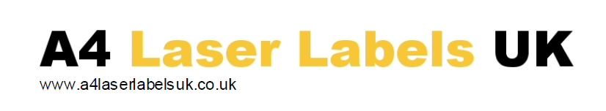

MULTIPURPOSE (LASER/COPIER/INKJET PRODUCTS)

Brown Ribbed Kraft paper with permanent adhesive.
A natural brown, unbleached, uncoated paper. The product is designed to be both environmentally friendly and to look environmentally friendly. Due to its make up it also biodegrades very quickly and is compostable. Best print results are obtained using ink-jet & hot fusion toner systems, the back ground colour does lend itself more to black print, but can be printed Mono or Colour.

Face material properties
Grammage 90 gsm
Caliper (thickness) 88 microns

Adhesive
A permanent, acrylic based adhesive with good tack & adhesion on a wide range of surfaces. Whilst maintaining good stability during laser printing.
Suitable for use on Dry, Non-Fatty food stuff according to European food stuffs certification.

Minimum application temp. +0°C
Storage range once applied -20°C to +80°C

Backing
A bleached kraft paper with good lay-flatness & stability

Thickness 59 microns
Grammage 55 gsm

Environmental & Handling.
Paper components are either ECF or TCF grade manufactured using pulp from sustainable, managed resources. All dimensions are nominal target specifications, but may vary. All products within our range are manufactured under ISO9001:2008. The product packaging is designed to maintain original ideal RH levels and will survive being stored in a wide range of temperatures, however, it is essential that the material is allowed to recover to normal print room temperatures for a min of 48 hours before use. Best print room conditions are 20 deg C and 50% RH.

