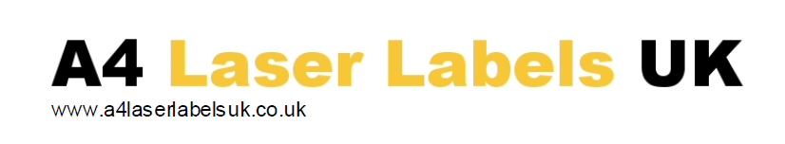

MULTIPURPOSE (LASER/COPIER PRODUCTS)

Matt White Polyolefin Permanent Adhesive – BS5609 part 2 approved

Face material properties
Suitable for a wide range of outdoor and robust labelling requirements especially haz-chem labels, where longevity and durability are required in a digitally printable material. Specifically designed for use on ‘hot fusion’ printer systems (laser & copier).

Grammage Approx 108 + or - 5 gsm
Calliper (thickness) 108 microns. + or – 8 Microns.

Adhesive
A clear permanent, water based emulsion acrylic based adhesive with good tack & adhesion on a wide range of surfaces. Specially designed for the labelling of chemical drums Approx 40 gsm. Our window trim feature is highly recommended for bespoke job due to the heavy coat-weight of adhesive to ensure and maintain good reliability.

Minimum application temp. +5⁰C
Storage range once applied -35⁰C to +80⁰C (Up to 195⁰C for short periods during printing).

Backing
A siliconized special kraft paper with good lay-flatness & stability

Thickness 116 microns
Grammage 119 gsm

Environmental: All papers used, are from managed sustainable resources and the laminate is manufactured without the use of solvents and under the controls of ISO 14001.

Handling and storage: The labels should be kept in their original bags & boxes and stored in dry conditions. The product should be used only after being moved to the print room for a minimum of 48 hours prior to use. Print room conditions should be at a temperature range of 19-22deg C and a humidity of 45 to 60%RH. If effectively stored a shelf life of two years can be expected though not guaranteed.

Special Note:
This material has been especially developed to be both a more cost effective and printer friendly version of our MWPE. The adhesive is very similar to our very popular MWPE grade. Users should still be wary of feed issues as it is still quite heavy but our development testing gave better reliability whilst printing than our MWPE. The material also has a very high coat weight of adhesive and as a result we are unable to entertain adhesion bleed complaints or feeding complaints on the grounds that these characteristics are critical to the end use, but do sadly make it sometimes a difficult product to run, however if our window trim feature is incorporated we can at least guarantee adhesive free edges!

